Lecture 1
Cytology as biological and medical science
The cellular theory: basic stage of formation, the modern formulation of substantive provisions, importance for biology and medicine.
The main cell compartments
Plasma membrane: structure, functions.
Cortical cytoplasm and cytoskeleton elements
Mechanisms of cellular movement
Centrosome
Mitochondrion
Cytology is the study about a structure and functions of cells.
In 1665 Robert Hooke built a compound microscope.
In 1771-1802 Bichat offers a term “histology” (the Greek histos – tissue, logia – science).
In 1819: Meier used a term “histology” for describing of tissues.
In 1825-1827: Y.Purkinje describes a nucleus (the Latin nux – nut). For the same reason the Greek prefix “kary” (the Greek karyon – nut).
The body is composed of cells, intercellular matrix, and a fluid substance, extracellular fluid (tissue fluid), which bathes these components. Extracellular fluid, which is derived from plasma of blood, carries nutrients, oxygen, and signaling molecules to cells of the body. Conversely, signaling molecules, waste products, and carbon dioxide released by cells of the body reach blood and lymph vessels by way of the extracellular fluid. Extracellular fluid and much of the intercellular matrix are not visible in routine histological preparations, yet their invisible presence must be appreciated by the student of histology.

The Cell Doctrine (Theory) given by T.Schwann and M.Schleiden (1839), Rudolf Virchoff (1858) included:
- All organisms consists of one or more cells.
- Cell is first living unit participating in formation of all organisms.
- All cells arises from previous cell (the Latin: Omnis cellula e cellulae).

Classification of Cells:
- Primary cells (the Latin – cellulae primordialis) - zygote and first cells arisen from division of zygote.
- Progenitor cells (cellulae fundatoria) can form all tissues.
- Pre-stem cells (cellulae proprecursoria) – from this cells arises one or few stem cells.
- Stem cells (cellulae precursoria) generates limited number of analogous cells without specialization. Further they preserve number and can derive the different types of specialized cells.
- Ancestor cells (cellulae progenetrix) arises from stem cells and cannot preserve number constant. They only can become to one specialized cell type.

Cell Potency:
- Totipotent cells are zygote and primary blastomeres.
- Pluripotent cells are:
- inner cell mass (embryoblast cells)
- epiblast cells
- teratoma cells
- primary germ cells.
- Multipotent cells are stem cells. They give arise to over two differentiated cells (for example, blood stem cells, neural stem cells ets).
- Oligopotent cells give arise to one or maximum two differentiated cells (for example, a stem cells of hair follicle can only differentiated to pigment cells; a stem cells of liver can differentiated both to hepatocyte and endothelial cells).
- Monopotent cells forms from either multipotent and oligopotent cells under the influence of necessary factors. The monopotent cells are specialized cells to fulfill concrete functions.
Cells are the basic functional units of complex organisms. Cells that are related or are similar to each other as well as cells that function in a particular manner or serve a common purpose are grouped together to form tissues. The four basic tissues (epithelium, connective tissues, muscle, and nervous tissue) that compose the body are assembled to form organs which, in turn, are collected into organ systems. The task of each organ system is specific, in that it performs a collection of associated functions, such as digestion, reproduction, and respiration.
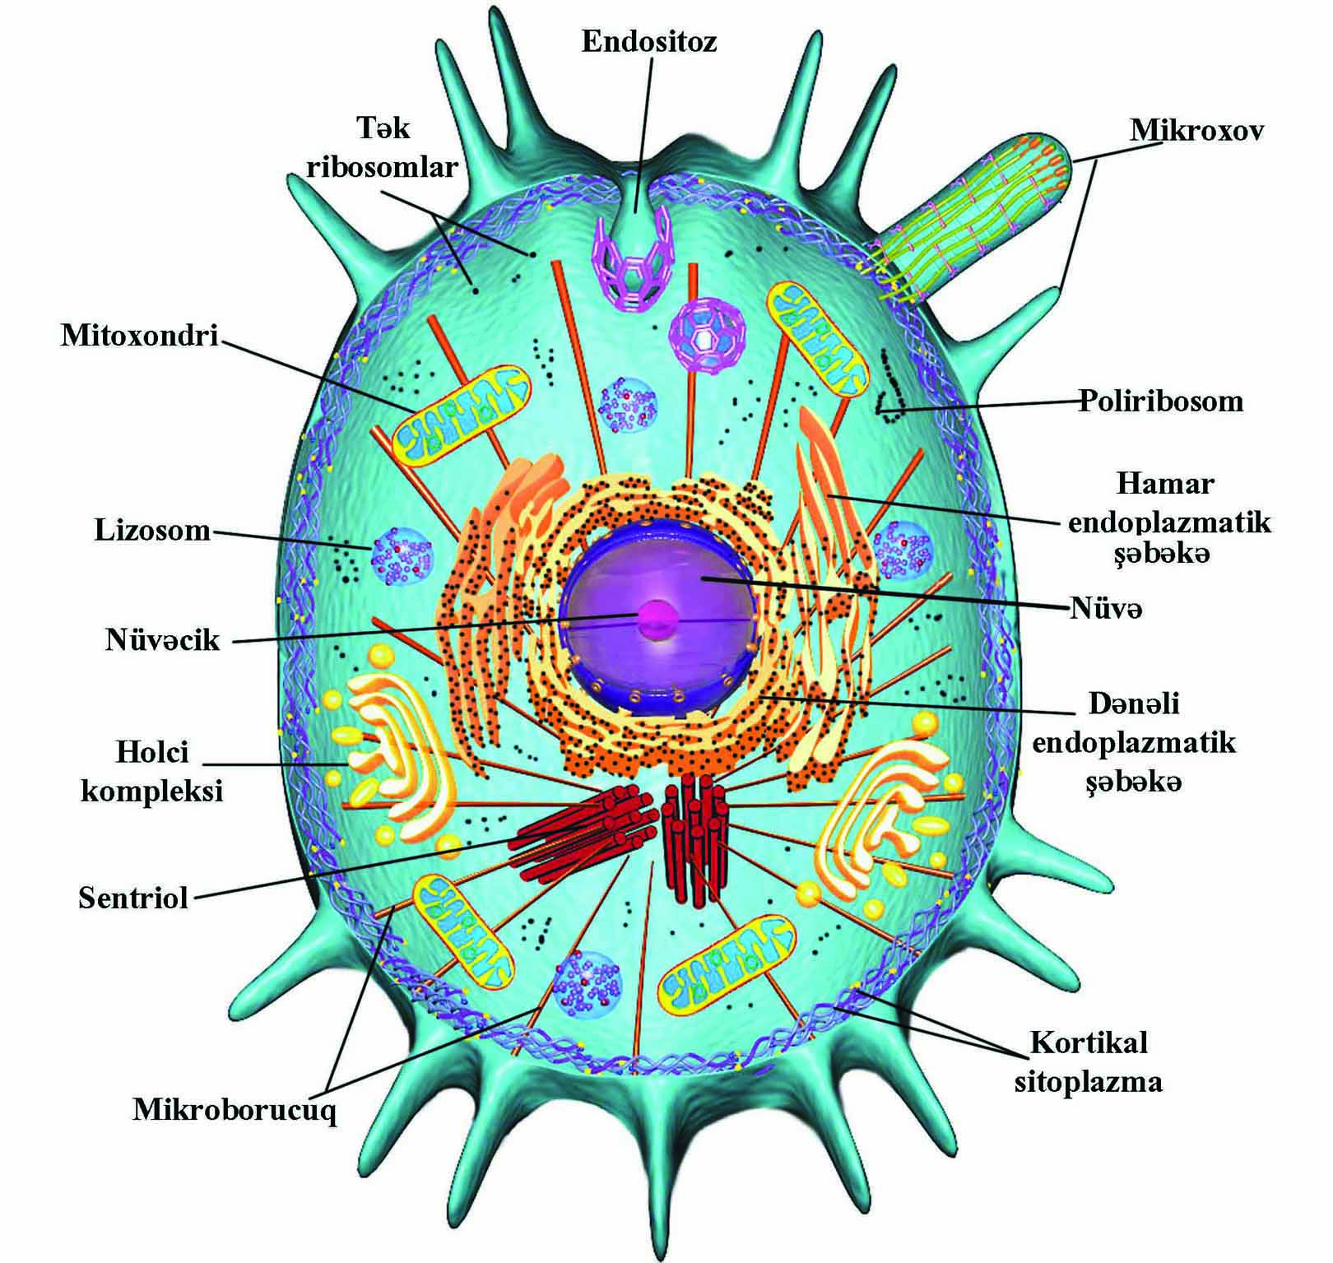
Figure 1.1.
Although the human body is composed of more than 200 different types of cells, each performing a different function, all cells possess certain unifying characteristics and thus can be described in general terms. Every cell is surrounded by a bilipid plasma membrane, possesses organelles that permit it to discharge its functions, synthesizes macromolecules for its own use or for export, produces energy, and is capable of communicating with other cells.
Protoplasm, the living substance of the cell, is subdivided into two compartments: cytoplasm, extending from the plasma membrane to the nuclear envelope, and karyoplasm, the substance forming the contents of the nucleus. The bulk of the cytoplasm is water, in which various inorganic and organic chemicals are dissolved and/or suspended. This fluid suspension is called the cytosol. The cytosol contains organelles, metabolically active structures that perform distinctive functions. Additionally, the shapes of cells, their ability to move, and the intracellular pathways within cells are maintained by a system of tubules and filaments known as the cytoskeleton. Finally, cells contain inclusions, which consist of metabolic by-products, storage forms of various nutrients, and inert crystals and pigments (Fig.1.1)

Each cell is bounded by a cell membrane (also known as the plasma membrane or plasmalemma) that functions in:
- Maintaining the structural integrity of the cell
- Controlling movements of substances in and out of the cell (selective permeability)
- Regulating cell-cell interactions
- Recognizing, via receptors, antigens and foreign cells as well as altered cells
- Acting as an interface between the cytoplasm and the external milieu
- Establishing transport systems for specific molecules
- Transducing extracellular physical or chemical signals into intracellular events.

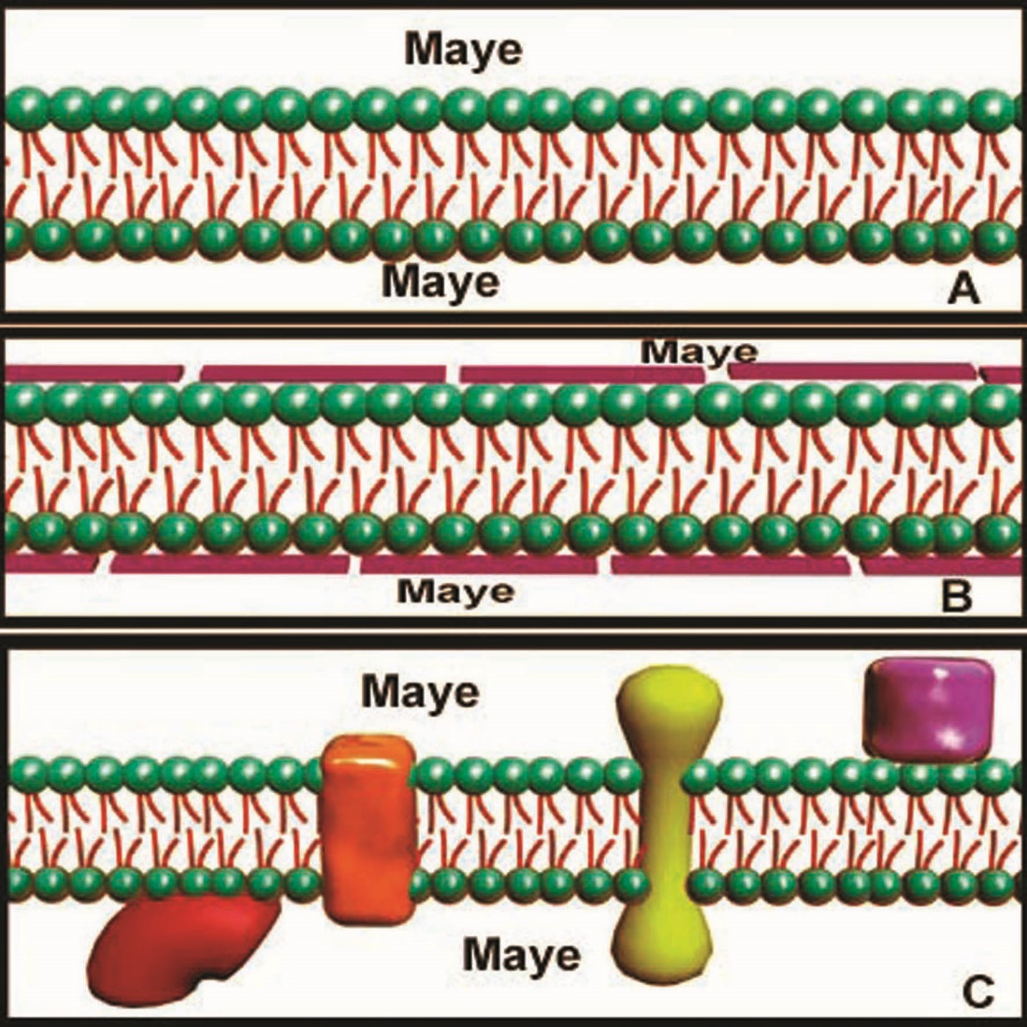
Figure 1.2.
Plasma membrane theory given by:
A Double lipid model – E.Gorter, K.Grendel (1925)
B Protein/lipid sandwich model – J.F.Danielli, H.Davson (1935)
C Mosaic fluid model – J.Singer, G.Nikolson (1972)

The plasmalemma is composed of a phospholipid bilayer and associated integral and peripheral proteins. The protein components of the plasmalemma either span the entire lipid bilayer as integral proteins or are attached to the cytoplasmic aspect (and at times the extracellular aspect) of the lipid bilayer as peripheral proteins. Because most integral proteins pass through the thickness of the membrane, they are also referred to as transmembrane proteins. Those regions of transmembrane proteins that project into the cytoplasm or the extracellular space are composed of hydrophilic amino acids, whereas the intramembrane region consists of hydrophobic amino acids. Transmembrane proteins frequently form ion channels and carrier proteins that facilitate the passage of specific ions and molecules across the cell membrane. Many of these transmembrane proteins are quite long and are folded so that they make several passes through the membrane and thus are known as multipass proteins. The cytoplasmic and extracytoplasmic aspects of these proteins commonly possess receptor sites that are specific for particular signaling molecules. Once these molecules are recognized at these receptor sites, the integral proteins can alter their conformation and can perform a specific function. Because the same integral membrane proteins have the ability to float like icebergs in the sea of phospholipids, this model is referred to as the fluid mosaic model of membrane structure (Fig. 1.2.). However, the integral proteins frequently possess only limited mobility, especially in polarized cells, in which particular regions of the cell serve specialized functions. Peripheral proteins do not usually form covalent bonds with either the integral proteins or the phospholipid components of the cell membrane. Although they are usually located on the cytoplasmic aspect of the cell membrane, they may also be on the extracellular surface. These proteins may form bonds either with the phospholipid molecules or with the transmembrane proteins. Frequently, they are associated with the secondary messenger system of the cell or with the cytoskeletal apparatus.
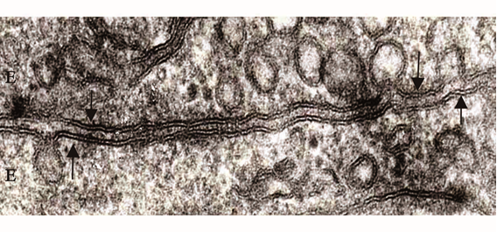
Figure 1.3.
Cell membranes are not visible with the light microscope. In electron micrographs, the plasmalemma is about 7.5 nm thick and appears as a trilaminar structure of two thin, dense lines with an intervening light area. Each layer is about 2.5 nm in width, and the entire structure is known as the unit membrane. The inner (cytoplasmic) dense line is its inner leaflet; the outer dense line is its outer leaflet. Each leaflet is composed of a single layer of phospholipids and associated proteins, usually in a 1:1 proportion by weight. In certain cases, such as myelin sheaths, however, the lipid component outweighs the protein component by a ratio of 4:1. The two leaflets, composing a lipid bilayer in which proteins are suspended, constitute the basic structure of all membranes of the cell (Fig. 1.3.).

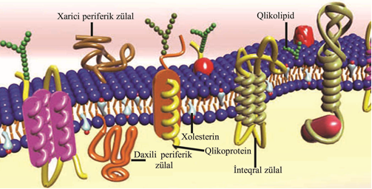
Figure 1.4.

Each phospholipid molecule of the lipid bilayer is composed of a polar head, located at the surface of the membrane, and two long nonpolar fatty acyl tails projecting into the center of the plasmalemma. The nonpolar fatty acyl tails of the two layers face each other within the membrane and form weak noncovalent bonds with each other, holding the bilayer together. Because the phospholipid molecule is composed of a hydrophilic head and a hydrophobic tail, the molecule is said to be amphipathic. The polar heads are composed of glycerol, to which a positively charged nitrogenous group is attached by a negatively charged phosphate group. The two fatty acyl tails, only one of which is usually saturated, are covalently bound to glycerol. Other amphipathic molecules, such as glycolipids and cholesterol, are also present in the cell membrane (Fig. 1.4.). The unsaturated fatty acyl molecules increase membrane fluidity, whereas cholesterol decreases it (although cholesterol concentrations much lower than normal increase membrane fluidity). Glycocalyx, composed usually of carbohydrate chains, coats the cell surface. A fuzzy coat, referred to as the cell coat, or glycocalyx, is often evident in electron micrographs of the cell membrane. This coat is usually composed of carbohydrate chains that are covalently attached to transmembrane proteins and/or phospholipid molecules of the outer leaflet. Additionally, some of the extracellular matrix molecules, adsorbed to the cell surface, also contribute to its formation. Its intensity and thickness vary, but it may be as thick as 50 nm on some epithelial sheaths, such as those lining regions of the digestive system. Because of its numerous negatively charged sulfate and carboxyl groups, the glycocalyx stains intensely with lectins as well as with dyes such as ruthenium red and Alcian blue, permitting its visualization with light microscopy. The most important function of the glycocalyx is protection of the cell from interaction with inappropriate proteins, from chemical injury, and from physical injury. Other cell coat functions include cell-cell recognition and adhesion, as occurs between endothelial cells and neutrophils, in blood clotting, and in inflammatory responses.

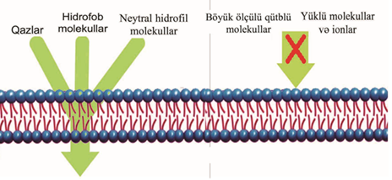
Figure 1.5.
The cell membrane forms a selectively permeable barrier between the cytoplasm and the external milieu. Six broad categories of membrane proteins have been defined in terms of their function:
- Pumps
- Channels
- Receptors
- Linkers
- Enzymes
- Structural proteins.

Membrane transport proteins are facilitate the movement of aqueous molecules and ions across the plasmalemma. A few nonpolar molecules (e.g., benzene, oxygen, nitrogen) and uncharged polar molecules (e.g., water, glycerol) can move across the cell membrane by simple diffusion down their concentration gradients (Fig. 1.5.).

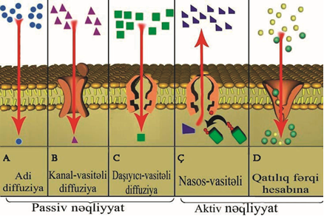
Figure 1.6.

Although the hydrophobic components of the plasma membrane limit the movement of polar molecules across it, the presence and activities of specialized transmembrane proteins facilitate the transfer of these hydrophilic molecules across this barrier. These transmembrane proteins and protein complexes form channel proteins and carrier proteins, which are specifically concerned with the transfer of ions and small molecules across the plasma membrane. Even when driven by a concentration gradient, however, movement of most ions and small molecules across a membrane requires the aid of membrane transport proteins, either channel proteins or carrier proteins. This process is known as facilitated diffusion. Because both types of diffusion occur without any input of energy other than that inherent in the concentration gradient, they represent passive transport. By expending energy, cells can transport ions and small molecules against their concentration gradients. Only carrier proteins can mediate such energy-requiring active transport (Fig. 1.6.).

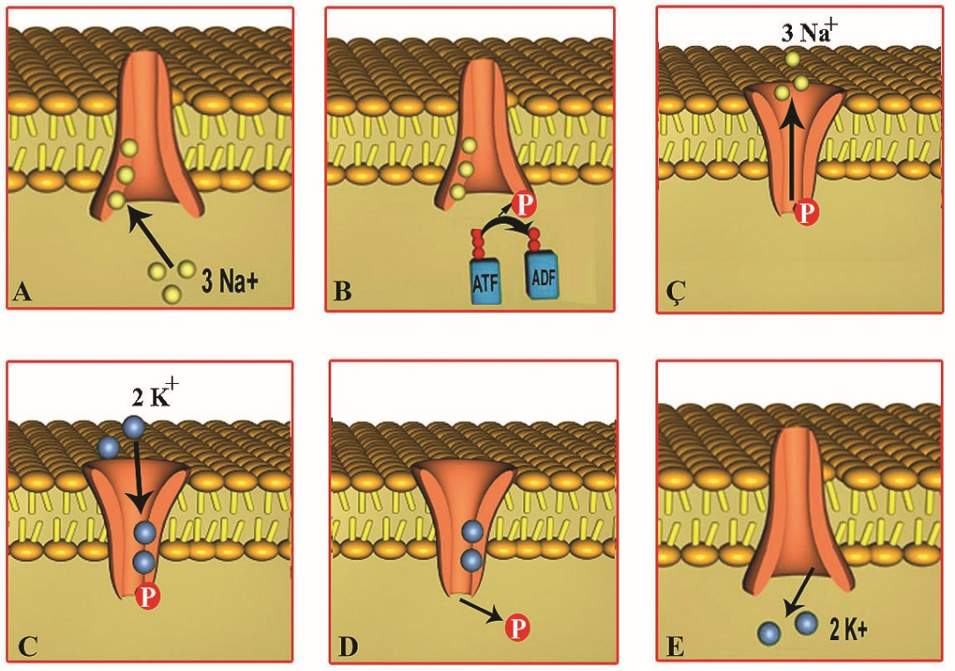
Figure 1.7.

PRIMARY ACTIVE TRANSPORT BY THE NA⁺-K⁺ PUMP. Normally, the concentration of Na⁺ is much greater outside the cell than inside, and the concentration of K⁺ is much greater inside the cell than outside. The cell maintains this concentration differential by expending adenosine triphosphate (ATP) to drive a coupled antiport carrier protein known as the Na⁺-K⁺ pump. This pump transports K⁺ ions into and Na⁺ ions out of the cell, each against a steep concentration gradient. Because this concentration differential is essential for the survival and normal functioning of practically every animal cell, the plasma membrane of all animal cells possesses a large number of these pumps. The Na⁺-K⁺ pump possesses two binding sites for K⁺ on its extracellular aspect and three binding sites for Na⁺ on its cytoplasmic aspect; thus, for every two K⁺ ions conveyed into the cell, three Na⁺ ions are transported out of the cell. Na⁺,K⁺-ATPase has been shown to be associated with the Na⁺-K⁺ pump. When three Na⁺ ions bind on the cytosolic aspect of the pump, ATP is hydrolyzed to adenosine diphosphate (ADP) and the released phosphate ion is used to phosphorylate the ATPase, resulting in alteration of the conformation of the pump, with the consequent transfer of Na⁺ ions out of the cell. Binding of two K⁺ ions on the external aspect of the pump causes dephosphorylation of the ATPase with an ensuing return of the carrier protein to its previous conformation, resulting in the transfer of the K⁺ ions into the cell. The constant operation of this pump reduces the intracellular ion concentration, resulting in decreased intracellular osmotic pressure. If the osmotic pressure within the cell were not reduced by the Na⁺-K⁺ pump, water would enter the cell in large quantities, causing the cell to swell and eventually to succumb to osmotic lysis (i.e., burst). Hence it is through the operation of this pump that the cell is able to regulate its osmolarity and, consequently, its volume. Additionally, this pump assists the K⁺ leak channels in the maintenance of the cell membrane potential. Because the binding sites on the external aspect of the pump bind not only K⁺ but also the glycoside ouabain, this glycoside inhibits the Na⁺-K⁺ pump (Fig. 1.7.).

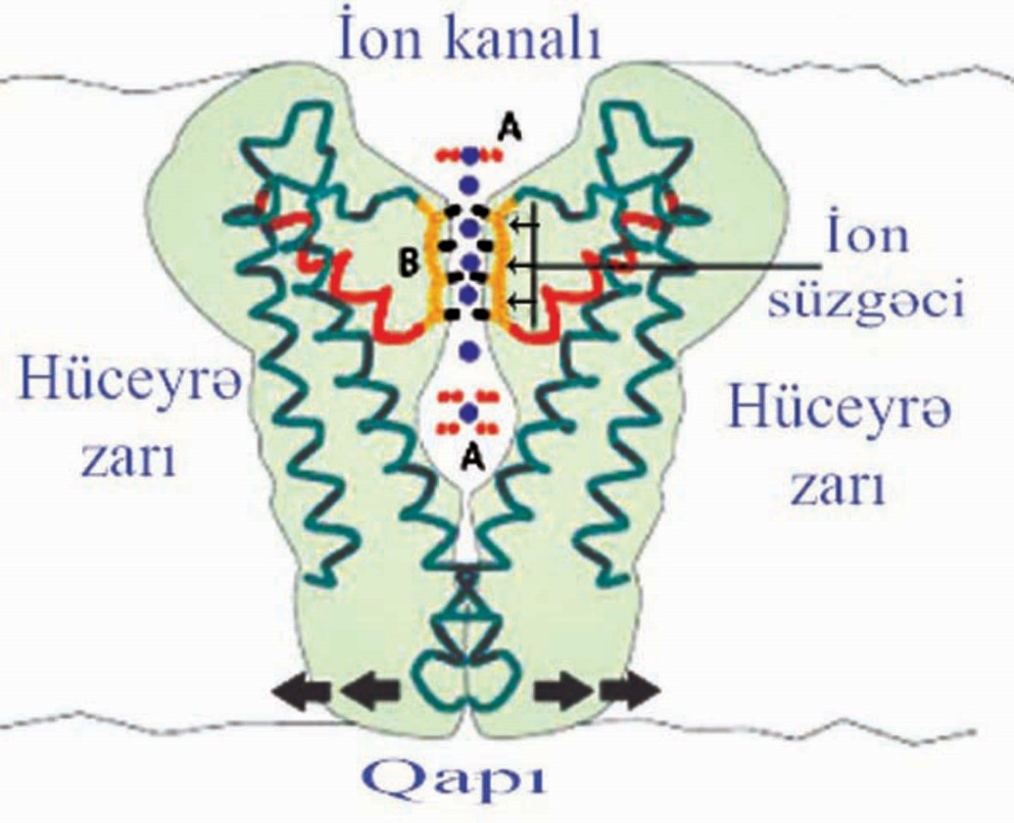
Figure 1.8.

Channel proteins may be gated or ungated; they are incapable of transporting substances against a concentration gradient. Channel proteins participate in the formation of hydrophilic pores, called ion channels, across the plasmalemma. In order to form hydrophilic channels, the proteins are folded so that the hydrophobic amino acids are positioned peripherally, interacting with the fatty acyl tails of the phospholipid molecules of the lipid bilayer, whereas the hydrophilic amino acids face inward, forming a polar inner lining for the channel. There are more than 100 different types of ion channels; some of these are specific for one particular ion but others permit the passage of several different ions and small water-soluble molecules. Although these ions and small molecules follow chemical or electrochemical concentration gradients for the direction of their passage, cells have the capability of preventing these substances from entering these hydrophilic tunnels by means of controllable gates that block their opening. Most channels are gated channels; only a few are ungated. Gated channels are classified according to the control mechanism required to open the gate (Fig. 1.8.).

VOLTAGE-GATED CHANNELS These channels go from the closed to the open position, permitting the passage of ions from one side of the membrane to the other. The most common example is depolarization in the transmission of nerve impulses. In some channels, such as Na⁺ channels, the open position is unstable and the channel goes from an open to an inactive position, in which the passage of the ion is blocked and for a short time (a few milliseconds) the gate cannot be opened again. This is the refractory period. The velocity of response to depolarization may also vary, and some of those channels are referred to as velocity-dependent.

LIGAND-GATED CHANNELS. Channels that require the binding of a ligand (signaling molecule) to the channel protein to open their gate are known as ligand-gated channels. Unlike voltage-gated channels, these channels remain open until the ligand dissociates from the channel protein; they are referred to as ion channel-linked receptors. Some of the ligands controlling these gates are neurotransmitters, whereas others are nucleotides.
Neurotransmitter-gated channels are usually located on the postsynaptic membrane. The neurotransmitter binds to a specific site on the protein, altering its molecular conformation, and thus opening the channel or gate and permitting the influx of a specific ion into the cell. Some neurotransmitters are excitatory, whereas others are inhibitory. Excitatory neurotransmitters (e.g., acetylcholine) facilitate depolarization; inhibitory neurotransmitters facilitate hyperpolarization of the membrane. In nucleotide-gated channels, the signal molecule is a nucleotide (e.g., cyclic adenosine monophosphate [cAMP] in olfactory receptors and cyclic guanosine monophosphate [cGMP] in rods of the retina) that binds to a site on the protein and, by altering the conformation of the protein complex, permits the flow of a particular ion through the ion channel.

MECHANICALLY-GATED CHANNELS In these channels, an actual physical manipulation is required to open the gate. An example of this mechanism is found in the hair cells of the inner ear. These cells, located on the basilar membrane, possess stereocilia that are embedded in a matrix known as the tectorial membrane. Movement of the basilar membrane causes a shift in the positions of the hair cells, resulting in the bending of the stereocilia. This physical distortion opens the mechanically-gated channels of the stereocilia located in the inner ear, permitting the entry of cations into the cell, depolarizing it. This event generates impulses that the brain interprets as sound.

G-PROTEIN-GATED ION CHANNELS Certain gated ion channels (e.g., muscarinic acetylcholine receptors of cardiac muscle cells) require the interaction between a receptor molecule and a G-protein complex (discussed later) with the resultant activation of the G protein. The activated G protein then interacts with the channel protein, modulating the ability of the channel to open or close. UNGATED CHANNELS One of the most common forms of an ungated channel is the potassium (K⁺) leak channel, which permits the movement of K⁺ across it and is instrumental in the creation of an electrical potential (voltage) difference between the two sides of the cell membrane. Because this channel is ungated, the transit of K⁺ ions is not under the cell's control; rather, the direction of ion movement reflects its concentration on the two sides of the membrane.

AQUAPORINS Currently, twelve different types of aquaporins have been identified. They are a family of multipass proteins that form channels designed for the passage of water from one side of the cell membrane to the other. Some of these channels are pure water transporters (e.g., AqpZ) whereas others transport glycerol (GlpF). These aquaporins discriminate in the transport of the two molecules by restricting the pore sizes in such a fashion that glycerol is too large to pass through pores of the AqpZ channel. An interesting property of aquaporins is that they are completely impermeable to protons, so that streams of protons cannot traverse the channel even though they readily pass through water molecules via the process of donor-acceptor configurations. Aquaporins interfere with this donor-acceptor model by forcing the water molecules to flip-flop halfway along the channel, so that water molecules enter the channel face up (hydrogen side up and oxygen side down) and leave the channel face down (oxygen side up and hydrogen side down). Properly functioning aquaporins in the kidney may transport as much as 20 L of water per hour, whereas improperly functioning aquaporins may result in diseases such as diabetes insipidus and congenital cataracts of the eye.
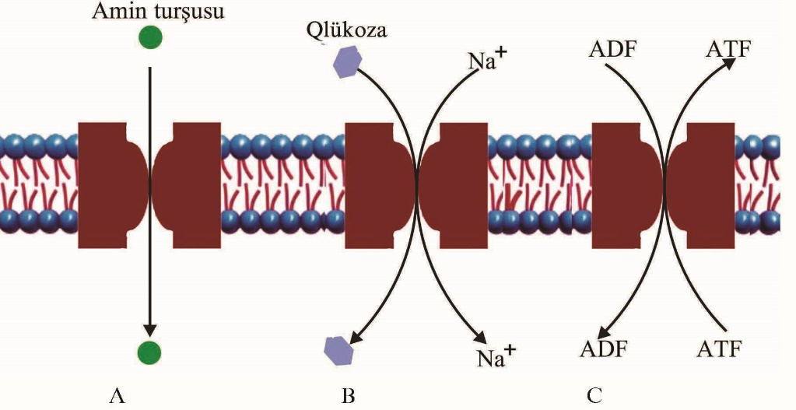
Figure 1.9.

Carrier Proteins. Carrier proteins can utilize ATP-driven transport mechanisms to ferry specific substances across the plasmalemma against a concentration gradient. Carrier proteins are multipass membrane transport proteins that possess binding sites for specific ions or molecules on both sides of the lipid bilayer. When a solute binds to the binding site, the carrier protein undergoes reversible conformational changes; as the molecule is released on the other side of the membrane, the carrier protein returns to its previous conformation. As stated previously, transport by carrier proteins may be passive-along an electrochemical concentration gradient-or active-against a gradient. Transport may be uniport-a single molecule moving in one direction-or coupled-two different molecules moving in the same (symport) or opposite (antiport) directions. Coupled transporters convey the solutes either simultaneously or sequentially.
SECONDARY ACTIVE TRANSPORT BY COUPLED CARRIER PROTEINS. The ATP-driven transport of Na⁺ out of the cell establishes a low intracellular concentration of that ion. The energy reservoir inherent in the sodium ion gradient can be utilized by carrier proteins to transport ions or other molecules against a concentration gradient. Frequently, this mode of active transport is referred to as secondary active transport, distinct from the primary active transport, which utilizes the energy released from the hydrolysis of ATP. The carrier proteins that participate in secondary active transport are either symports or antiports. As a Na⁺ ion binds to the extracellular aspect of the carrier protein, another ion or small molecule (e.g., glucose) also binds to a region on the same aspect of the carrier protein, inducing in it a conformational alteration. The change in conformation results in the transfer and subsequent release of both molecules on the other side of the membrane (Fig. 1.9.).

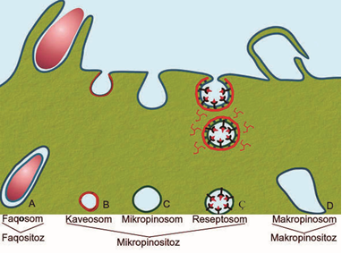
Figure 1.10.

Endocytosis, endosomes, and lysosomes are involved in the ingestion, sequestering, and degradation of substances internalized from the extracellular space. The process whereby a cell ingests macromolecules, particulate matter, and other substances from the extracellular space is referred to as endocytosis. The endocytosed material is engulfed in a vesicle appropriate for its volume. If the vesicle is large (>250 nm in diameter), the method is called phagocytosis (cell eating) and the vesicle is a phagosome. If the vesicle is small (<150 nm in diameter), the type of endocytosis is called pinocytosis (cell drinking) and the vesicle is a pinocytotic vesicle. Endocytosis is divided into two categories: phagocytosis and pinocytosis.
The process of engulfing larger particulate matter, such as microorganisms, cell fragments, and cells (e.g., defunct red blood cells), is usually performed by specialized cells known as phagocytes. The most common phagocytes are the white blood cells, the neutrophils, and the monocytes. When monocytes leave the bloodstream and enter the connective tissue domain to perform their task of phagocytosis, they become known as macrophages. Phagocytes can internalize particulate matter because they possess receptors that recognize certain surface features of the material to be engulfed. Two of the better understood of these surface features come from the study of immunology and are the constant regions (Fc regions) of antibodies and a blood-borne series of proteins known as complement. Because the variable region of the antibody binds to the surface of a microorganism, the Fc region projects away from its surface. Macrophages and neutrophils possess Fc receptors that bind the Fc regions of the antibody upon contact. This relationship acts as a signal for the cell to extend pseudopods, surround the microorganism, and internalize the microorganism by forming a phagosome. Complement on the surface of the microorganism probably assists phagocytosis in a similar manner, because macrophages also possess complement receptors on their surface. Interaction between complement and its receptor presumably activates the cell to form pseudopods and engulf the offending microorganism.
Pinocytosis. Because most cells export substances into the intercellular space, they continually add the membranes of vesicles that transport those substances from the trans Golgi network to the plasma membrane. These cells, in order to maintain their shape and size, must continually remove the excess membrane and return it for recycling. This cycle of membrane shuffling during exocytosis and endocytosis is known as membrane trafficking, the movement of membranes to and from various compartments of the cell. In most cells, pinocytosis is the most active transporting process and contributes most to the recapturing of membranes (Fig. 1.10.).

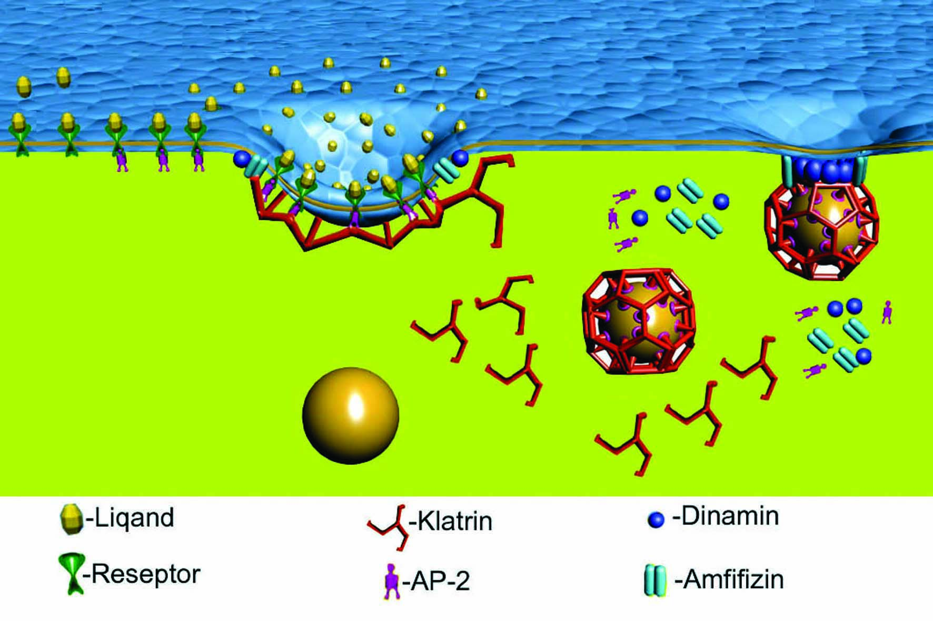
Figure 1.11.

RECEPTOR-MEDIATED ENDOCYTOSIS. Many cells specialize in the pinocytosis of several types of macromolecules. The most efficient form of capturing these substances depends on the presence of receptor proteins (cargo receptors) in the cell membrane. Cargo receptors are transmembrane proteins that become associated with the particular macromolecule (ligand) extracellularly and with a clathrin coat intracellularly. The assembly of clathrin triskelions beneath the cargo receptors pulls on the plasma membrane, forming a clathrin-coated pit, which eventually becomes a pinocytotic vesicle, enclosing the ligand as a droplet of fluid about to drip from a surface. To release this pinocytotic vesicle, several molecules of dynamin, a GTPase, surround the constricted neck of the vesicle, pinch its neck closed, and the pinocytotic vesicle is released from its membrane origin into the cytoplasm. This method of endocytosis permits the cell to increase the concentration of the ligand (e.g., low-density lipoprotein) within the pinocytotic vesicle. A typical pinocytotic vesicle may have as many as 1000 cargo receptors of several types, for they may bind different macromolecules. Each cargo receptor is linked to its own adaptin, the protein with a binding site for the cytoplasmic aspect of the receptor, as well as a binding site for the clathrin triskelion (Fig. 1.11.).
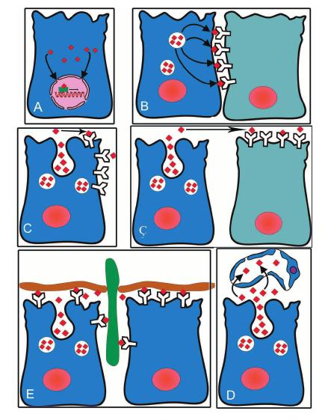
Figure 1.12.

Cell Signaling. Cell signaling is the communication that occurs when signaling cells release signaling molecules that bind to cell surface receptors of target cells. When cells communicate with each other, the one that sends the signal is called the signaling cell; the cell receiving the signal is called the target cell. Transmission of the information may occur either by the secretion or presentation of signaling molecules, which contact receptors on the target cell membrane (or intracellularly either in the cytosol or in the nucleus), or by the formation of intercellular pores known as gap junctions, which permit the movement of ions and small molecules (e.g., cAMP) between the two cells.. The signaling molecule, or ligand, may be either secreted and released by the signaling cell or may remain bound to its surface and be presented by the signaling cell to the target cell (Fig. 1.12.).
- Intracrine signaling – secreted ligand in the cytoplasm without releasing from cell enters into nucleus and activated transcription factors of protein synthesis (Fig. 1.12A).
- Juxtacrine signaling – ligand enters into plasma membrane, binds with receptors of neighbour cells, and changes the function of them (Fig. 1.12 B).
- Autocrine signaling – released from the cell ligand binds with the receptors of the same cell (Fig. 1.12C).
- Paracrine signaling – occurs when the ligand is released into the intercellular environment and affects cells in its immediate vicinity (Fig. 1.12Ç).
- Matricrine signaling – ligand binds with extracellular matrix components (Fig. 1.12E).
- Endocrine signaling – ligand enters the bloodstream to be ferried to target cells situated at a distance from the signaling cell (Fig. 1.12D).
A cell-surface receptor usually is a transmembrane protein, whereas an intracellular receptor is a protein that resides in the cytosol or in the nucleus of the target cell. Ligands that bind to cell-surface receptors usually are polar molecules; those that bind to intracellular receptors are hydrophobic and thus can diffuse through the cell membrane. In the most selective signaling process, synaptic signaling, the signaling molecule, a neurotransmitter, is released so close to the target cell that only a single cell is affected by the ligand. A more generalized but still local form of signaling, paracrine signaling, occurs when the signaling molecule is released into the intercellular environment and affects cells in its immediate vicinity. Occasionally, the signaling cell is also the target cell, resulting in a specialized type of paracrine signaling known as autocrine signaling. The most widespread form of signaling is endocrine signaling; in this case, the signaling molecule enters the bloodstream to be ferried to target cells situated at a distance from the signaling cell.
Signaling Molecules. Signaling molecules bind to extracellular or intracellular receptors to elicit a specific cellular response. Most signaling molecules are hydrophilic (e.g., acetylcholine) and cannot penetrate the cell membrane. Therefore, they require receptors on the cell surface. Other signaling molecules are either hydrophobic, such as steroid hormones, or are small nonpolar molecules, such as nitric oxide (NO), which have the ability to diffuse through the lipid bilayer. These ligands require the presence of an intracellular receptor. Hydrophilic ligands have a very short life span (a few milliseconds to minutes at most), whereas steroid hormones last for extended time periods (several hours to days). Signaling molecules often act in concert, in that several different ligands are required before a specific cellular response is elicited. Moreover, the same ligand or combination of ligands may elicit different responses from different cells. For instance, acetylcholine causes skeletal muscle cells to contract, cardiac muscle cells to relax, endothelial cells of blood vessels to release nitric oxide, and parenchymal cells of some glands to release the contents of their secretory granules. Binding of signaling molecules to their receptors activates an intracellular second messenger system, initiating a cascade of reactions that result in the required response. A hormone, for example, binds to its receptors on the cell membrane of its target cell. The receptor alters its conformation, with the resultant activation of adenylate cyclase, a transmembrane protein, whose cytoplasmic region catalyzes the transformation of ATP to cAMP, one of the most common second messengers. cAMP activates a cascade of enzymes within the cell, thus multiplying the effects of a very few molecules of hormones on the cell surface. The specific intracellular event depends on the enzymes located within the cell; thus, cAMP activates one set of enzymes within an endothelial cell and another set of enzymes within a follicular cell of the thyroid gland. Therefore, the same molecule can have a different effect in different cells. The system is known as a second messenger system because the hormone is the first messenger that activates the formation of cAMP, the second messenger. Other second messengers include calcium (Ca²⁺), cGMP, inositol triphosphate (IP₃), and diacylglycerol. Steroid hormones (e.g., cortisol) can also diffuse through the cell membrane. Once in the cytosol, they bind to steroid hormone receptors (members of the intracellular receptor family), and the ligand-receptor complex activates gene expression, or transcription (the formation of messenger ribonucleic acid [mRNA]). Transcription may be induced directly, resulting in a fast primary response, or indirectly, bringing about a slower, secondary response. In the secondary response, the mRNA codes for the protein that is necessary to activate the expression of additional genes.
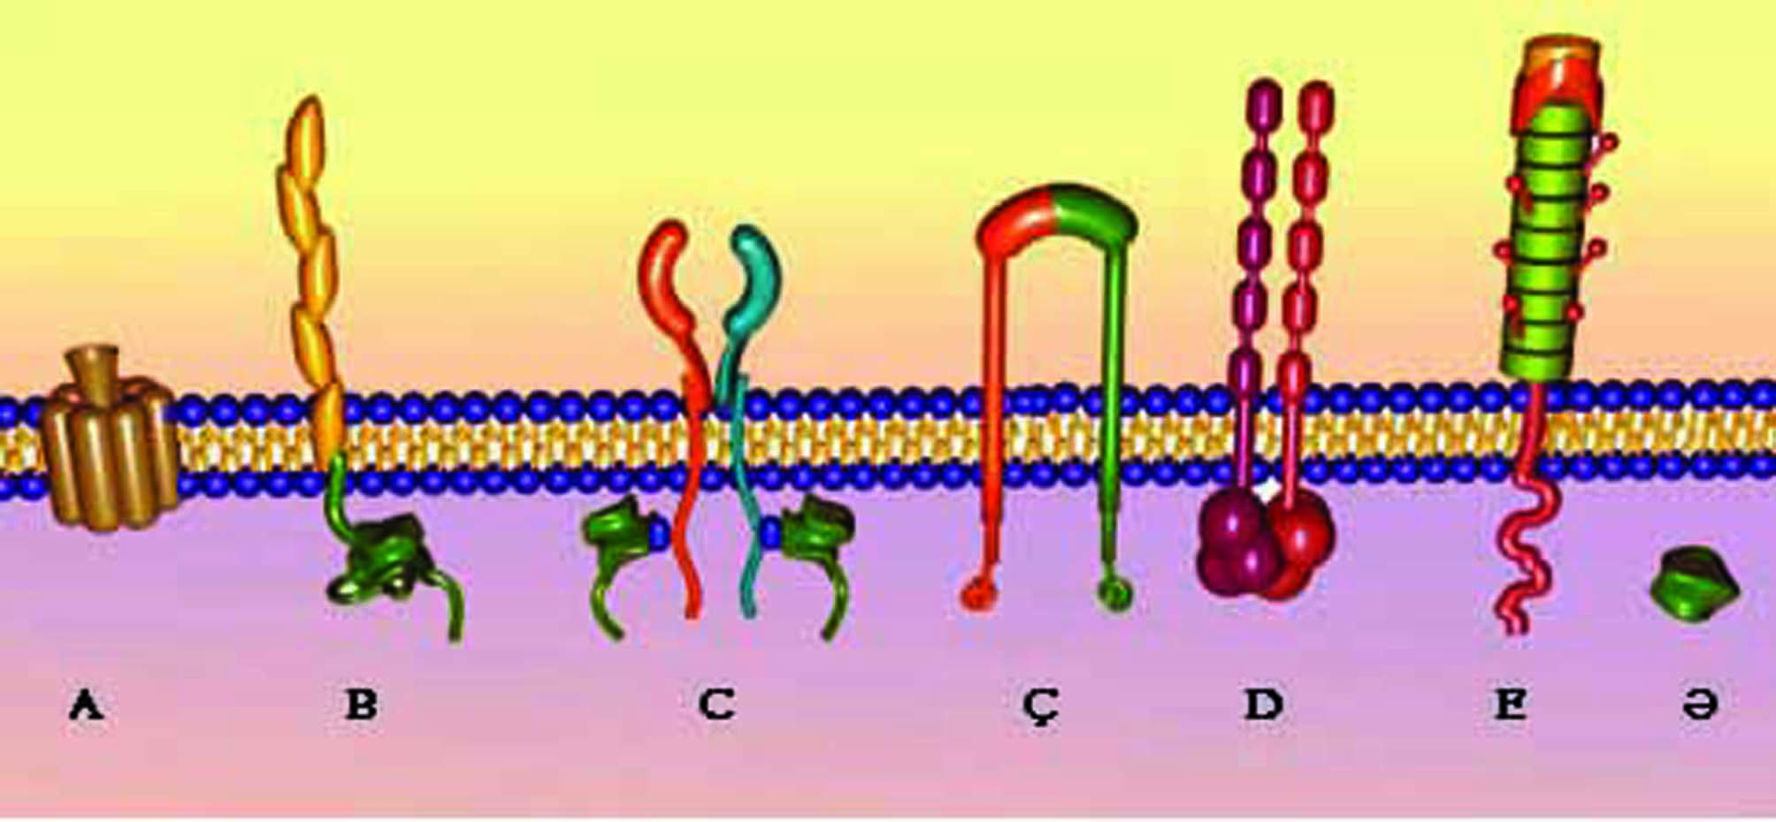
Figure 1.13.

Cell-Surface Receptors. Cell-surface receptors are of three types: ion channel-linked, enzyme-linked, and G-protein-linked. Most cell-surface receptors are integral glycoproteins that function in recognizing signaling molecules and in transducing the signal into an intracellular action. The three main classes of receptor molecules are ion channel-linked receptors (see earlier), enzyme-linked receptors, and G-protein-linked receptors (Fig. 1.13.).
ENZYME-LINKED RECEPTORS These receptors are transmembrane proteins whose extracellular regions act as receptors for specific ligands. When a signaling molecule binds to the receptor site, the receptor's intracellular domain becomes activated so that it now possesses enzymatic capabilities. These enzymes then either induce the formation of second messengers, such as cGMP, or permit the assembly of intracellular signaling molecules that relay the signal intracellularly. This signal then elicits the required response by activating additional enzyme systems or by stimulating gene regulatory proteins to initiate the transcription of specific genes.
G-PROTEIN-LINKED RECEPTORS These receptors are multipass proteins whose extracellular domains act as receptor sites for ligands. Their intracellular regions have two separate sites, one that binds to G proteins and another that becomes phosphorylated during the process of receptor desensitization. Most cells possess two types of GTPases (monomeric and trimeric), each of which has the capability of binding guanosine triphosphate (GTP) and guanosine diphosphate (GDP). Trimeric GTPases, or G proteins, are composed of a large α subunit and two small β and γ subunits, and can associate with G-protein-linked receptors. G proteins act by linking receptors with enzymes that modulate the levels of the intracellular signaling molecules (second messengers) cAMP or Ca²⁺. There are several types of G proteins, including:
- Stimulatory (G_{s})
- Inhibitory (G_{i})
- Pertussis toxin-sensitive (G_{o})
- Pertussis toxin-insensitive (G_{Bq})
- Transducin (G_{t})

CYTOSKELETON The cytoskeleton has three major components: thin filaments, intermediate filaments, and microtubules. The cytoplasm of animal cells contains a cytoskeleton, an intricate three-dimensional meshwork of protein filaments that are responsible for the maintenance of cellular morphology. Additionally, the cytoskeleton is an active participant in cellular motion, whether of organelles or vesicles within the cytoplasm, regions of the cell, or the entire cell. The cytoskeleton has three components: thin filaments (microfilaments), intermediate filaments, and microtubules.

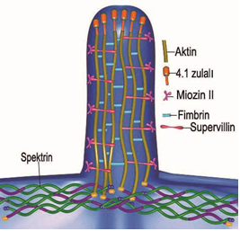

Figure 1.14.

Spectrin molecules are flexible, rod-like tetramers that assist the cell in maintaining the structural integrity of the cortex. The proteins fimbrin and villin are responsible for forming actin filaments into closely packed parallel bundles that form the core of microspikes and microvilli, respectively. These bundles of actin filaments are anchored in the terminal web, a region of the cell cortex composed of a network of intermediate filaments and the protein spectrin (Fig. 1.14.).

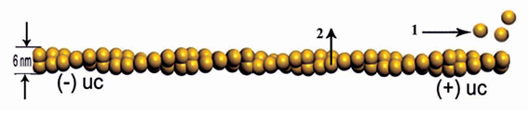
Figure 1.15.

Thin Filaments Thin filaments are actin filaments that interact with myosin to bring about intracellular or cellular movement. Thin filaments (microfilaments) are composed of two chains of globular subunits (G-actin) coiled around each other to form a filamentous protein, F-actin . Actin constitutes about 15% of the total protein content of non-muscle cells. Only about half of their total actin is in the filamentous form, because the monomeric G-actin form is bound by small proteins, such as profilin and thymosin, which prevent their polymerization. Actin molecules, present in the cells of many different vertebrate and invertebrate species, are very similar to each other in their amino acid sequence, attesting to their highly conserved nature. Thin filaments are 6-nm thick and possess a faster-growing plus end and a slower-growing minus end. When the actin filament reaches its desired length, members of a family of small proteins, capping proteins, attach to the plus end, terminating the lengthening of the filament. The process of shortening of actin filaments is regulated in the presence of ATP, ADP, and Ca²⁺ by capping proteins, such as gelsolin, which prevent polymerization of the filament. The cell membrane phospholipid polyphosphoinositide has the opposite effect: it removes the gelsolin cap, permitting elongation of the actin filament (Fig. 1.15.). Depending on their isoelectric point, there are three classes of actin: α-actin of muscle, and β-actin and γ-actin of non-muscle cells. Although actin participates in the formation of various cellular extensions as well as in assembling structures responsible for motility, its basic composition is unaltered. It is capable of fulfilling its many roles via its association with different actin-binding proteins. The most commonly known of these proteins is myosin, but numerous other proteins, such as α-actinin, spectrin, fimbrin, filamin, gelsolin, and talin, also bind to actin to perform essential cellular functions. Actin filaments form bundles of varied lengths, depending on the function that they perform in non-muscle cells. These bundles form three types of associations:
- Contractile bundles
- Gel-like networks
- Parallel bundles
Contractile bundles, such as those responsible for the formation of cleavage furrows (contractile rings) during mitotic division, are usually associated with myosin. Their actin filaments are arranged loosely, parallel to each other, with the plus and minus ends alternating in direction. These assemblies are responsible for movement not only of organelles and vesicles within the cell but also for cellular activities, such as exocytosis and endocytosis, as well as the extension of filopodia and cell migration. The myosin associated with these contractile bundles may be one of several types: myosin-I through myosin-IX. Myosin-II forms thick filaments (15 nm in diameter) and moves actin filaments, especially in muscle cells. Myosin-V can bind not only to actin filaments but also to other cytoplasmic components, such as vesicles, moving them along an actin filament from one position in the cell to another, whereas myosin-I has been implicated in the formation and retraction of actin-directed protrusions of the cell cortex, such as in the formation of pseudopods Gel-like networks provide the structural foundation of much of the cell cortex. Their stiffness is due to the protein filamin, which assists in the establishment of a loosely organized network of actin filaments resulting in localized high viscosity. During the formation of filopodia, the gel is liquefied by proteins such as gelsolin, which, in the presence of ATP and high Ca²⁺, cleaves the actin filaments and, by forming a cap over their plus end, prevents them from lengthening. Actin is also important in the establishment and maintenance of focal contacts of the cell with extracellular matrix . At focal contacts, the integrin (a transmembrane protein) of the cell membrane binds to structural glycoproteins, such as fibronectin, of the extracellular matrix, permitting the cell to maintain its attachment. Simultaneously, the intracellular region of the integrin contacts the cytoskeleton via intermediary proteins that attach it to actin filaments. The mode of attachment involves integrin binding to talin, which contacts both vinculin and the actin filament. Vinculin binds to α-actinin, the actin-binding protein that assembles actin into contractile bundles. These contractile bundles, referred to as stress fibers in fibroblasts maintained in tissue culture, resemble myofibrils of striated muscle. Stress fibers may extend between two focal points or a focal point and intermediate filaments and assist the cell in exerting a tensile force on the extracellular matrix (as in the wound contraction function of fibroblasts).
Intermediate Filaments. Intermediate filaments and their associated proteins assist in the establishment and maintenance of the three-dimensional framework of the cell. Electron micrographs display a category of filaments in the cytoskeleton whose diameter of 8 to 10 nm places them between thick and thin filaments and they are consequently named intermediate filaments . These filaments and their associated proteins accomplish the following:
- Provide structural support for the cell
- Form a deformable three-dimensional structural framework for the cell
- Anchor the nucleus in place
- Provide an adaptable connection between the cell membrane and the cytoskeleton
- Furnish a structural framework for the maintenance of the nuclear envelope as well as its reorganization subsequent to mitosis
When microbeads bound to integrin molecules of the cell membrane are micromanipulated, as when one pulls on them, the tensile forces produce distortion of the cytoskeleton, with resultant deformation of the nucleus and rearrangement of the nucleoli. Thus, it appears that the cytoskeleton, and specifically the intermediate filaments, react to forces generated in the extracellular matrix, and by forcing modulations in the shape and location of cellular constituents, they protect the structural and functional integrity of the cell from external stresses and strains. Biochemical investigations have determined that there are several categories of intermediate filaments that share the same morphological and structural characteristics. These rope-like intermediate filaments are constructed of tetramers of rod-like proteins that are tightly bundled into long helical arrays. The individual subunit of each tetramer differs considerably for each type of intermediate filament. The categories of intermediate filaments include keratins, desmin, vimentin, glial fibrillary acidic protein, neurofilaments, and nuclear lamins. Several intermediate filament-binding proteins have been discovered. As they bind to intermediate filaments, they link them into a three-dimensional network that facilitates the formation of the cytoskeleton. Four of the best known of these proteins have the following characteristics:
- 1 Filaggrin binds keratin filaments into bundles.
- 2 Synamin and plectin bind desmin and vimentin, respectively, into three-dimensional intracellular meshworks.
- 3 Plakins assist the maintenance of contact between the keratin intermediate filaments and hemidesmosomes of epithelial cells as well as actin filaments with neurofilaments of sensory neurons
Microtubules are long, straight, rigid tubular-appearing structures that act as intracellular pathways. Microtubules are polarized, having a rapidly growing plus end as well as a minus end, which must be stabilized or it will depolymerize, thus shortening the microtubule. The minus end is stabilized by being embedded in a γ-tubulin molecule. Microtubules are dynamic structures that frequently change their length by undergoing growth spurts and then becoming shorter; both processes occur at the plus ends, so that the average half-life of a microtubule is only about 10 minutes. The main functions of microtubules are to:
- Provide rigidity and maintain cell shape
- Regulate intracellular movement of organelles and vesicles
- Establish intracellular compartments
- Provide the capability of ciliary (and flagellar) motion
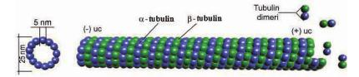
Figure 1.16.

Each microtubule consists of 13 parallel protofilaments composed of heterodimers of the globular polypeptide α- and β-tubulin subunits, each consisting of about 450 amino acids and each having a molecular mass of about 50,000 daltons . Polymerization of the heterodimers requires the presence of magnesium (Mg²⁺) and GTP (Fig. 1.16.). During cell division, rapid polymerization of existing as well as new microtubules is responsible for the formation of the spindle apparatus.
Microtubule-Associated Proteins Microtubule-associated proteins are motor proteins that assist in the translocation of organelles and vesicles inside the cell. In addition to tubulin heterodimers, microtubules also possess microtubule-associated proteins (MAPs) bound to their periphery at 32-nm intervals. There are various types of MAPs, ranging in molecular weight from about 50,000 to more than 300,000 daltons. Their primary functions are to prevent depolymerization of microtubules and to assist in the intracellular movement of organelles and vesicles. Movement along a microtubule occurs in both directions and is toward both the plus end and the minus end. The two major families of microtubule motor proteins, the MAPs dynein and kinesin, bind to the microtubule as well as to vesicles (and organelles). It is believed that different members of each motor protein family transport their cargo at disparate, meticulously controlled rates and that different organelles have their own particular motor protein. In the presence of ATP, dynein moves the vesicle toward the minus end of the microtubule. Kinesin effects vesicular (and organelle) transport in the opposite direction, toward the plus end, but the mechanism of ATP utilization by these MAPs is not understood. Additionally, dynein and kinesin participate in the organization of the minus and plus ends, respectively.

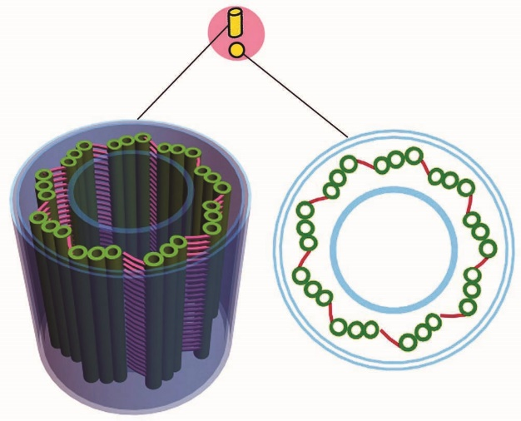
Figure 1.17.

The centrosome is the region of the cell in the vicinity of the nucleus that houses the centrioles (see later), as well as several hundred ring-shaped γ-tubulin ring complex molecules. These γ-tubulin molecules act as nucleation sites for microtubules, which are long, straight, rigid, hollow-like cylindrical structures 25 nm in outer diameter, with a luminal diameter of 15 nm. Therefore, the centrosome is considered to be the MTOC of the cell.
Centrioles Centrioles are small, cylindrical structures composed of nine microtubule triplets; they constitute the core of the microtubule organizing center, or the centrosome. Centrioles are small, cylindrical structures, 0.2 μm in diameter and 0.5 μm in length. Usually, they are paired structures, arranged perpendicular to each other, and are located in the microtubule organizing center, the centrosome, in the vicinity of the Golgi apparatus. The centrosome assists in the formation and organization of microtubules as well as in its self-duplication before cell division. Centrioles are composed of a specific arrangement of nine triplets of microtubules arranged around a central axis. Each microtubule triplet consists of one complete and two incomplete microtubules fused to each other, so that the incomplete ones share three protofilaments. The complete microtubule "A" is positioned closest to the center of the cylinder; "C" is the farthest away. Adjacent triplets are connected to each other by a fibrous substance of unknown composition, extending from microtubule A to microtubule C. Each triplet is arranged so that it forms an oblique angle with the adjacent triplet and a straight angle with the fifth triplet (Fig. 1.17.). Centrioles function in the formation of the centrosome, and during mitotic activity they are responsible for the formation of the spindle apparatus. Additionally, centrioles are the basal bodies that guide the formation of cilia and flagella.
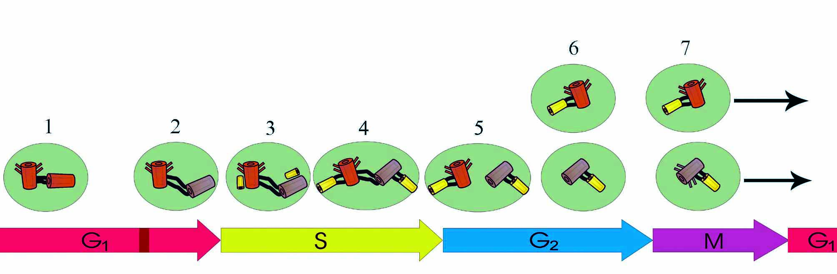
Figure 1.18.

During the S phase of the cell cycle, each centriole of the pair replicates, forming a procentriole in some unknown manner, at 90 degrees to itself. This procentriole initially possesses no microtubules, but tubulin molecules begin to polymerize closest to the parent centriole, with the plus end growing away from the parent. The actual replication of the centriole requires the presence of γ-tubulin rings, structures that do not become part of but serve to direct the elongation of the forming microtubules by occupying the forming plus and minus ends. It is believed that the γ-tubulin rings and pericentrin serve as beams that support the developing centriole. Additionally, δ-tubulins, related to the α- and β-tubulin superfamily, are also required to form the triplet structure of the microtubule arrays (Fig. 1.18.).

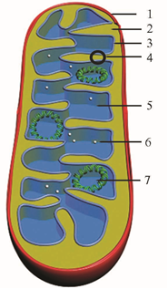
Figure 1.19.

Mitochondria possess their own DNA and perform oxidative phosphorylation and lipid synthesis Mitochondria are flexible, rod-shaped organelles, about 0.5 to 1 μm in girth and sometimes as much as 7 μm in length. Most animal cells possess a large number of mitochondria (as many as 2000 in each liver cell) because, via oxidative phosphorylation, they produce ATP, a stable storage form of energy that can be used by the cell for its various energy-requiring activities. Each mitochondrion possesses a smooth outer membrane and a folded inner membrane. The folds of the inner membrane, known as cristae, greatly increase the surface area of the membrane. The number of cristae possessed by a mitochondrion is related directly to the energy requirement of the cell; thus, a cardiac muscle cell mitochondrion has more cristae than an osteocyte mitochondrion has. The narrow space (10 to 20 nm in width) between the inner and outer membranes is called the intermembrane space, whereas the large space enclosed by the inner membrane is termed the matrix space (intercristal space).
Outer Mitochondrial Membrane and Intermembrane Space. The outer mitochondrial membrane possesses a large number of porins, multipass transmembrane proteins. Each porin forms a large aqueous channel through which water-soluble molecules, as large as 10 kD, may pass. Because this membrane is relatively permeable to small molecules, including proteins, the contents of the intermembrane space resemble the cytosol. Additional proteins located in the outer membrane are responsible for the formation of mitochondrial lipids.
Inner Mitochondrial Membrane. The inner mitochondrial membrane is folded into cristae to provide a larger surface area for ATP synthase and the respiratory chain. The inner mitochondrial membrane, which encloses the matrix space, is folded to form cristae. This membrane is richly endowed with cardiolipin, a phospholipid that possesses four, rather than the usual two, fatty acyl chains. The presence of this phospholipid in high concentration makes the inner membrane nearly impermeable to ions, electrons, and protons (Fig. 1.19.). In certain regions, the outer and inner mitochondrial membranes contact each other; these contact sites act as pathways for proteins and small molecules to enter and leave the matrix space. The contact sites are composed of carrier proteins for the transport and regulatory proteins for the recognition of markers denoting the transportability of the specific macromolecules. These same contact sites are also used for the transport of proteins into the intermembrane space, provided that the proteins bear markers specific for entry into that space. Additional sites are also available for the transport of macromolecules that are destined for the outer or inner mitochondrial membrane or for the matrix. At these sites, the two membranes do not contact one another, but both inner and outer membranes possess receptor molecules that recognize not only the macromolecule that is being transported but also cytosolic carrier molecules (and chaperones) responsible for the delivery of that particular macromolecule.
Matrix. The matrix space is filled with a dense fluid composed of at least 50% protein, which accounts for its viscosity. Much of the protein component of the matrix is enzymes responsible for the stepwise degradation of fatty acids and pyruvate to the metabolic intermediate acetyl CoA and the subsequent oxidation of this intermediate in the tricarboxylic acid (Krebs) cycle. Mitochondrial ribosomes, tRNA, mRNA, and dense spherical matrix granules (30 to 50 nm in diameter) are also present in the matrix. The function of matrix granules is not understood. They are composed of phospholipoprotein, although in some cells, especially cells of bone and cartilage, they may also bind magnesium and calcium. Moreover, in injured cells whose cytosolic Ca²⁺ levels are dangerously high, matrix granules may sequester calcium to protect the cell from calcium toxicity. The matrix also contains the double-stranded mitochondrial circular deoxyribonucleic acid (cDNA) and the enzymes necessary for the expression of the mitochondrial genome. cDNA contains information for the formation of only 13 mitochondrial proteins, 16S and 12S rRNA, and genes for 22 tRNAs. Therefore, most of the codes necessary for the formation and functioning of mitochondria are located in the genome of the nucleus. Origin and Replication of Mitochondria Because of the presence of the mitochondrial genetic apparatus, it is believed that mitochondria were free-living organisms that either invaded or were phagocytosed by anaerobic eukaryotic cells, developing a symbiotic relationship. The mitochondrion-like organism received protection and nutrients from its host and provided its host with the capability of reducing its O₂ content and simultaneously supplying it with a stable form of chemical energy. Mitochondria are self-replicating, in that they are generated from preexisting mitochondria. These organelles enlarge in size, replicate their DNA, and undergo fission. The division usually occurs through the intracristal space of one of the centrally located cristae. The outer mitochondrial membrane of the opposing halves extends through that intracristal space; the halves meet and fuse with each other, thus dividing the mitochondrion into two nearly equal halves. The two new mitochondria move away from each other. The average life span of a mitochondrion is about 10 days

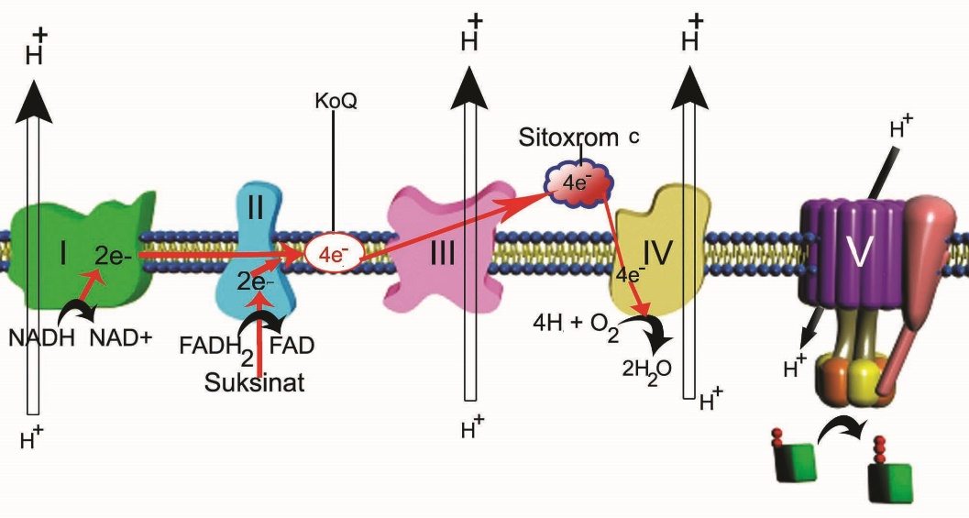
Figure 1.20.

Viewed in negatively stained preparations, the inner membrane displays the presence of a large number of lollipop-like inner membrane subunits, protein complexes known as ATP synthase, which are responsible for the generation of ATP from ADP and inorganic phosphate. The globular head of the subunit, about 10 nm in diameter, is attached to a narrow, flattened, cylinder-like stalk, 4 nm wide and 5 nm long, projecting from the inner membrane into the matrix space. Additionally, a large number of protein complexes, the respiratory chains, are present in the inner membrane. Each respiratory chain is composed of three respiratory enzyme complexes: (1) NADH dehydrogenase complex, (2) cytochrome b-c₁ complex, and (3) cytochrome oxidase complex. These complexes form an electron transport chain that is responsible for the passage of electrons along this chain and, more important, that function as proton pumps that transport H⁺ from the matrix into the intermembrane space, establishing an electrochemical gradient that provides energy for the ATP-generating action of ATP synthase (Fig. 1.20.). Oxidative Phosphorylation Oxidative phosphorylation is the process responsible for the formation of ATP. Acetyl CoA, formed through the β-oxidation of fatty acids and the degradation of glucose, is oxidized in the citric acid cycle to produce, in addition to carbon dioxide (CO₂), large quantities of the reduced cofactors nicotinamide adenine dinucleotide (NADH) and flavin adenine dinucleotide (FADH₂). Each of these cofactors releases a hydride ion (H⁺) which is stripped of its two high-energy electrons and becomes a proton (H⁺). The electrons are transferred to the electron transport chain and during mitochondrial respiration reduce oxygen (O₂) to form water (H₂O). According to the chemiosmotic theory, the energy released by the sequential transfer of the electrons is used to transport H⁺ from the matrix into the intermembrane space, establishing a high proton concentration in that space exerting a proton motive force. Only through ATP synthase may these protons leave the intermembrane space and reenter the matrix. As the protons pass down this electrochemical gradient, the energy differential in the proton motive force is transformed into the stable high-energy bond of ATP by the globular head of the inner membrane subunit, which catalyzes the formation of ATP from ADP + P_{i}, where P_{i} is inorganic phosphate. The newly formed ATP either is utilized by the mitochondrion or is transported, through an ADP-ATP antiport system, into the cytosol. During the entire process of glycolysis, tricarboxylic acid cycle, and electron transport, each glucose molecule yields 36 molecules of ATP In some cells, such as the brown fat cells of hibernating animals, oxidation is uncoupled from phosphorylation, resulting in the formation of heat instead of ATP. This uncoupling is dependent on the presence of proton shunts, known as thermogenins, that resemble ATP synthase but that cannot generate ATP. As the protons pass through thermogenins to reenter the matrix, the energy of the proton motive force is transformed into heat. It is this heat that awakens the animal from its state of hibernation.

